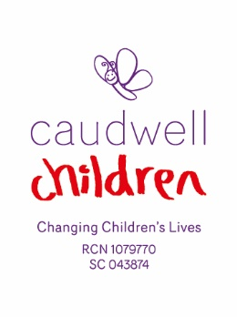

**JOB DESCRIPTION**

**POST TITLE:** Finance Assistant

**RESPONSIBLE TO:** Financial Controller

**HOURS:** 37.5 hours per week

**LEAVE ENTITLEMENT:** 27 days annual leave per annum exclusive of Bank Holidays (increasing with length of service)

**TERM OF POST:** Permanent

**LOCATION:** Keele, Staffordshire

**SALARY:** £24,500

**PURPOSE OF THE POST**

We are currently seeking an experienced Finance Assistant on a full-time basis to work within our established Finance Department, supporting senior management and working closely with colleagues in the Finance Department and wider organisation.

The successful applicant will be fully conversant in Bank Reconciliation, Sales Ledger and Credit Control and have a working knowledge of Purchase Ledger. The position will also involve input and reconciliation of income in our CRM system.

**DUTIES AND RESPONSIBILITIES**

* Daily Bank Reconciliation
* Reconciliation of Credit Cards payments
* Banking including cheques and cash
* Liaising with other departments regarding income
* Input of Income into a CRM system
* Ensuring the CRM system reconciles to the Finance system
* Sales Ledger - raising of invoices
* Credit Control and resolving any queries
* Gift Aid
* Working knowledge of Purchase Ledger to cover during holidays/sickness
* General ad hoc Accounting Duties

**PERSON SPECIFICATION**

**Essential Criteria**

* Good all round Accounting knowledge gained either by Qualification or Experience
* Good working knowledge of Microsoft Excel and it’s functions

**Desirable Criteria**

* Exchequer Accounting Software experience
* Razors Edge CRM experience
* Experience of working in the Charity/Third Sector would be advantageous.
* Experience of working in CQC/ISO regulated organisations would also be advantageous.
* Occasional UK travel may be required.
* Some flexibility to meet the needs of the business may be required.
* A general knowledge of Health & Safety regulations would be advantageous.

**DISCLOSURE AND BARRING SERVICE CHECKS**

The Charity is committed to safeguarding children and young people and therefore adopts a safer recruitment approach through a robust recruitment and selection process. All posts within the Charity are subject to DBS checks, in line with the Rehabilitation of Offenders Act (1974). Dependent on the role, one of the following DBS checks will be carried out:

* Standard disclosure
* Enhanced disclosure
* Enhanced disclosures with children’s and/or adults’ barred list check(s):

This role is eligible for a standard DBS check.